80.05.00e
From John Buchanan
RB MSS M111, Library, Royal Botanic Gardens Melbourne.

OFFICES OF —
N.Z. GEOLOGICAL SURVEY.
NEW ZEALAND INSTITUTE.
METEOROLOGICAL DEPART.

Colonial Museum of New Zealand,
Wellington, 187
Baron F. Von Mueller

Sir.
I am glad that you have asked me the question concerning Cyathea medullaris. There exists two distinct varieties of this species, first pointed out to me by the Maories north of Auckland, who have distinguishing names for both:
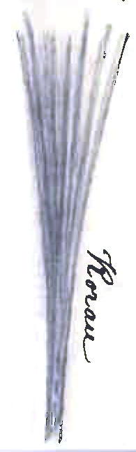
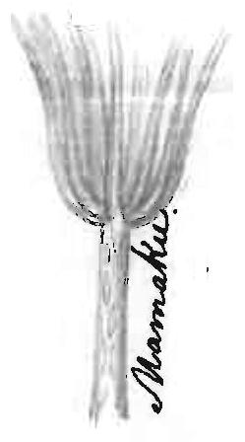
No 1. "Mamaku" in this variety the stipes form a distinct crown where they join the stem as shewn in the sketch.
In No 2. "Korau" the stipes grow straight from the stem which is generally more slender than in Mamaku.
Both varieties are abundant near Wellington although they are not distinguished by name, "Mamaku" being the only Maori name for Cyathea medullaris here
It may perhaps be worthy of notice whether differences exist in the fronds or other parts of the two varieties, for although I have often called the attention of others to this variety, I have always neglected to examine for myself.
I am sorry I was not in possession of the Australian Flora when this work on the New Zealand grasses was commenced, as the nomenclature might have by its aid been greatly improved. as one instance, the recent discovery of Deyeuxia scabra in New Zealand has made confusion of Agrostis, several species of which should have been placed in Deyeuxia. however, as the work is chiefly for the use of New Zealand Squatters, any names will do for the purpose of distinction, and again in a benevolent point of view, it will give Kirk a wider scope to distinguish himself in pointing out its shortcomings, which he intends doing.
Remains Yours respectfully
John Buchanan

Agrostis
Cyathea medullaris
Deyeuxia scabra

MS found with a specimen of Cyathea cunninghamii (MEL 224426) collected in the Dandenong Ranges, Vic, in October 1879. The item is dated to May 1880 on the presumption that M's inquiry to which Buchanan refers was prompted by information he had received about Cyathea medullaris in G. Marriner to M, 28 April 1880 (in this edition as 80-04-28a), and on the basis of Buchanan's reference to the 'recent discovery of Deyeuxia scabra in New Zealand'. In a paper that Buchanan read to the Wellington Institute on 21 February 1880 (Buchanan (1880a)), he included this species in a list of species recently added to the flora of NZ, with a reference to Plate 26 in his Indigenous grasses (Buchanan (1880)); but on that plate, the item was labelled as Agrostis quadriseta.
80-05-00e_image01.jpg.
80-05-00e_image02.jpg.
Grasses were dealt with in Bentham (1863-78), vol. 7, pp. 449-670; the volume was published in March 1878 (TL2).
Buchanan (1880).
John Buchanan (1819-1898).

